1.

Design a python code (application) which should able to open up 2 Excel files (let's say **excel_file_new** and **excel_file_old**).

These files will both be data tables laid out similar to the below example.

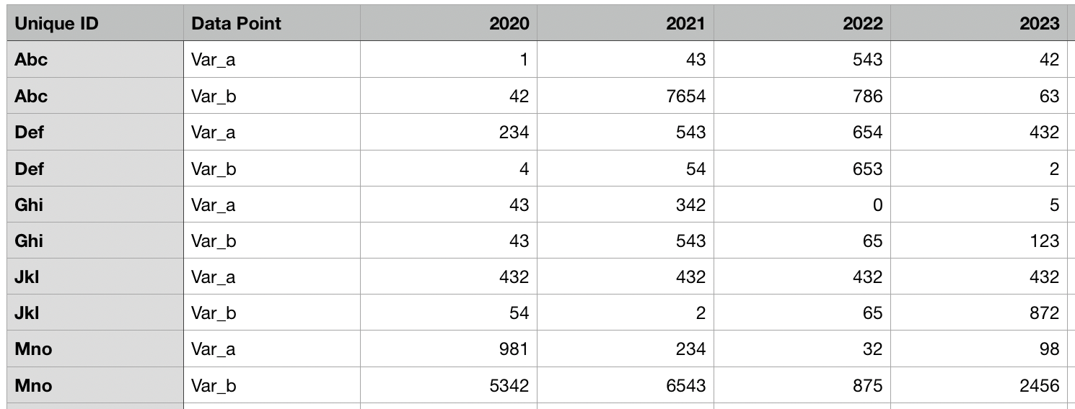

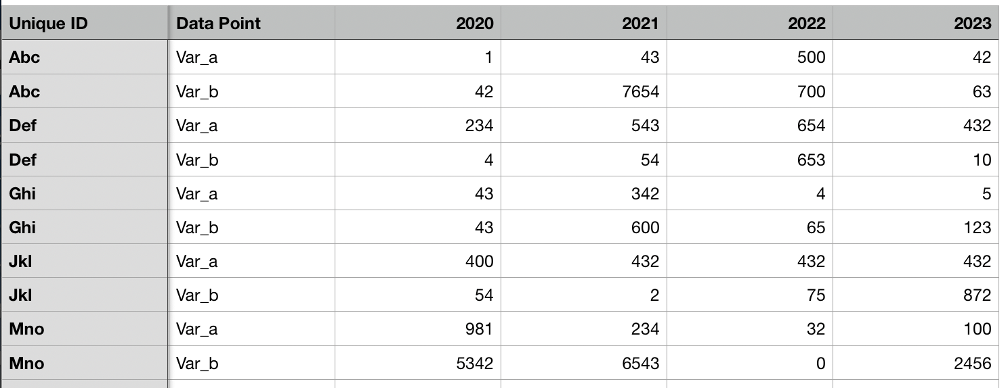

It should to be able to tell for each Unique ID what Data Point what has changed. Keep in mind that this will need to be dynamic as the number and order of the data points may change. The below screen shot is just a simple subtraction of excel_file_new - excel_file_old. If there is a number in the column then we know that something has change. Also keep in mind that while the example shown has the exact same set of data, it is normal for new data to exist in the excel_file_new, making that data table larger. The application should be able to tell what unique IDs exist in the new file and not the other (and vise versa).

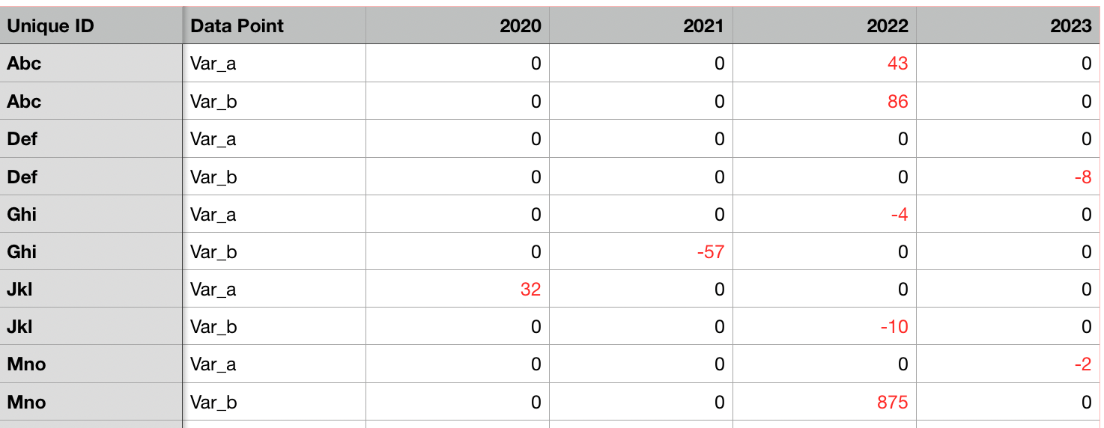

2.